Derived Columns 1 :

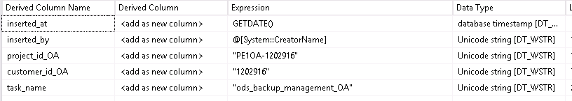

Data type Conversion :

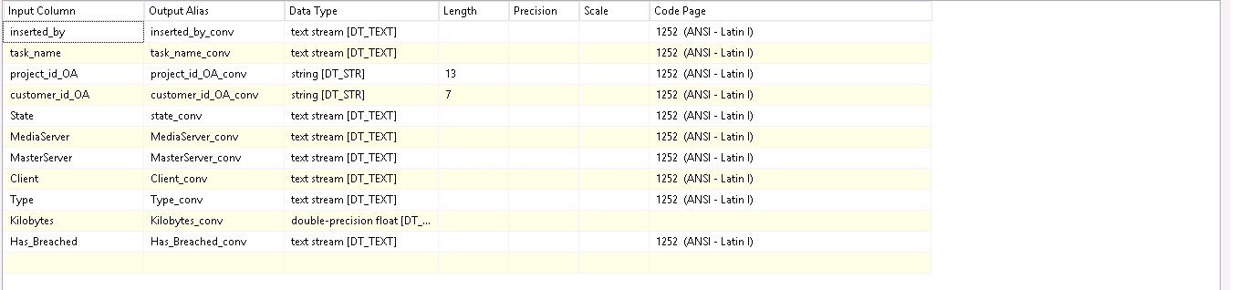

Derived column : 2



Destination Mappings :

